 DOLOMITI CUP 2025 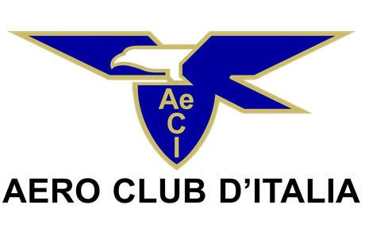
ENTRY FORM
Belluno/ITALY 03-04 MAY 2025

Address: Aero Club Paracadutismo Belluno, Via Caduti 14 Sett.1944 n°32 – zip code: 32100 - BELLUNO (ITALY)
www.skydivebelluno.it Email: cmarchet@alice.it

TEAM: ................................................................................................-

 | SURNAME Firstname | Nation | ID number | FAI licence N° | Sex (M/F) |  | Year of birth | for Organisation
 |  |  |  |  |  |  |  | Reg | € | paid | Not paid
A |  |  |  |  |  |  |  |  | 200
B |  |  |  |  |  |  |  |  | 200
C |  |  |  |  |  |  |  |  | 200
D |  |  |  |  |  |  |  |  | 200
E |  |  |  |  |  |  |  |  | 200

It is declared that all athletes are in possession of the documentation listed below: 1) FAI Sporting licence, 2) skydiving licence, 3) insurance, 4) emergency check .

Team leader: ....................................................................... Email: ..........................................................................................

Date: .......................... Signature: ..................................................

